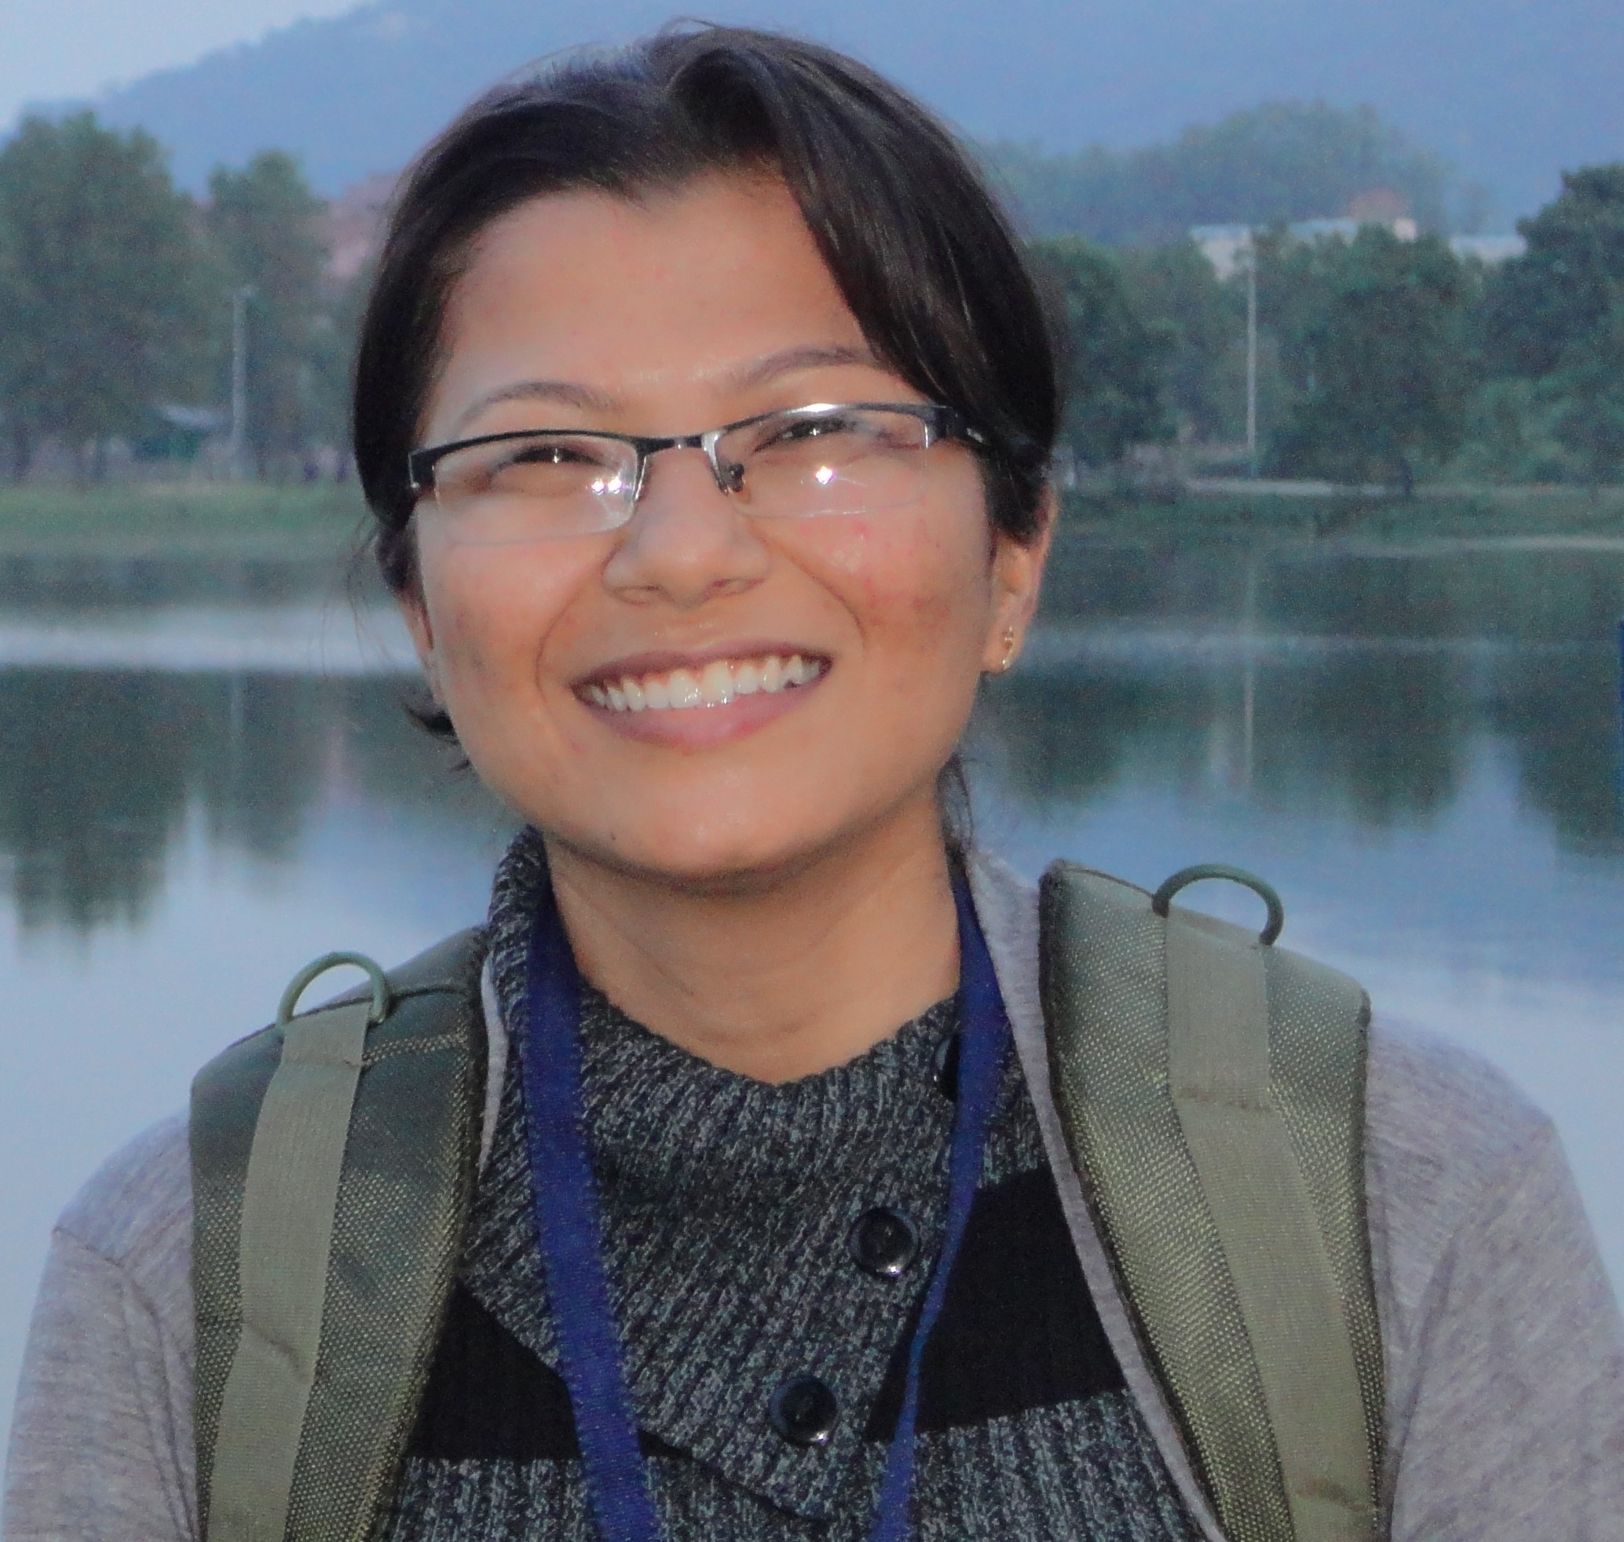Bharti V. Nathwani, Ph.D.

*Faculty of Statistics, Econometrics and Mathematics*

[bharti.nathwani17912@gmail.com](mailto:bharti.nathwani17912@gmail.com) +91-9426980636

# Employment History

August 2019 – **Associate Professor.** Department of Mathematics, Amity School of Applied Sciences, Amity University, Mumbai, Maharashtra.

*· · · ·*

February 2018 – May 2019 **Assistant Professor.** Department of Engineering Sciences,

Ramrao Adik Institute of Technology, Dr. D. Y. Patil

Vidyanagar, Nerul, Navi Mumbai, Maharashtra.

July 2011 – February 2018 **Assistant Professor.** Department of Applied Sciences and

Humanities, Sardar Vallabhbhai Patel Institute of Technology,

Vasad, Gujarat.

June 2009 –June 2011 **Assistant Professor.** Department of Applied Sciences, Charotar University of Science and Technology, Changa, Gujarat.

January 2009 – June 2009 **Lecturer.** Department of Applied Sciences and Humanities,

Sardar Vallabhbhai Patel Institute of Technology, Vasad,

Gujarat.

July 2008 – January 2009 **Teaching Assistant.** Department of Mathematics, Faculty of

Science, The Maharaja Sayajirao university of Baroda, Gujarat.

# Education

2012 – 2017 **Ph.D. Mathematics, The Maharaja Sayajirao University of Baroda, Gujarat, India** in Special Functions.

Thesis title: *A Unification of Generalized Mittag-Leffler Functions, Family of Bessel Function and their q-Analogues .*

2007 – 2010 **M.Phil. Mathematics, The Maharaja Sayajirao University of Baroda, Gujarat, India** in Special Functions.

Thesis title: *Basic Inverse Series Relations and Associated Polynomials*. *Distinction.* M.Phil. Mathematics topper.

### 2005 – 2007 M.Sc. Mathematics, The Maharaja Sayajirao University of Baroda, Gujarat, India.

*Distinction.* Gold Medalist - Gold Medal for M.Sc. Mathematics, Gold Medal for M.Sc. .

### 2002 – 2005 B.Sc. (Hons) Mathematics, The Maharaja Sayajirao University of Baroda, Gujarat, India.

*First Class Honours.* University Prizes for Outstanding Performance.

# Certification

2022 **Python Data Structures** An online non-credit course authorized by University of Michigan and offered through Coursera in January, 2022.

2021 **Programming for Everybody (Getting Started with Python)** An online non-credit course authorized by University of Michigan and offered through Coursera in December, 2021.

**Numpy Tutorial** provided by Great Learning Academy in October, 2021.

**Python Programming** provided by Great Learning Academy in September, 2021.

2018 **Maharashtra SET**, Maharashtra State Eligibility Test qualified for eligibility for lectureship in the subject Mathematical Sciences held on 28th January, 2018.

2013 **Gujarat SET**, Gujarat State Eligibility Test qualified for eligibility for lectureship in the subject Mathematical Sciences held on 22nd September, 2013.

# Awards and Achievements

2012 **Best Paper Presentation Award**, M. I. Qureshi best paper presentation award during International Conference on Special Functions and their Applications (ICSFA-2012) and Symposium on Life and Works of Ramanujan organized by Department of Applied Math- ematics and Humanities, Saradar Vallabhbhai National Institute of Technology, Surat held during June 27-29, 2012 and presented a paper entitled "A q-Extension of Generalized Mittag-Leffler Function and Family of Bessel Function ".

2007 **Gold Medal**, Smt. Shiv Gauri Chandulal Lallubhadarwala Gold Medal in M. Sc..

**Gold Medal**, Shri Ranchhodlal Chhotalal Shah Gold Medal in Mathematics in M. Sc..

2005 **Univesity Prize for Outstanding Student Performance**, Post Graduate Merit Scholarship in B.Sc..

**Univesity Prize for Outstanding Student Performance,** Smt. Shamistha Kohil Dave Scholarship in B.Sc.

**Univesity Prize for Outstanding Student Performance,** Professor V. M. Shah Prize in B.Sc.

**Univesity Prize for Outstanding Student Performance,** Shri Ganesh Shridhar Apte Memorial Prize in B.Sc.

**Univesity Prize for Outstanding Student Performance**, Wrangler S. D. Manerikar Memorial Prize in B.Sc.

**Univesity Prize for Outstanding Student Performance**, Dr. M. S. Patel Prize in B.Sc.

# Research Publications

## Books

2017 B. V. Nathwani, A Unification of Generalized Mittag-Leffler Functions, Family of Bessel Function and Their q-Analogues, Thesis(Ph.D.)-Maharaja Sayajirao University of Bar- oda(India), 2017, 299pp. ISBN 978-1392-57307-5, ProQuest LLC

## Publications

2021 S. Badarla, B. V. Nathwani and et al, Estimating fluctuating volatility time series returns for a cluster of international stock markets: A case study for Switzerland, Austria, China and Hong Kong, Annals of the University of Craiova, Physics, Vol. 31(2021), 43-52

2020 B. V. Nathwani, Inequalities involving Mittag-Leffler type q-Konhauser polynomial, Studia Universitatis Babes-Bolyai Mathematica, Vol. 65(3)(2020), 379-401

2019 R. R. Sanjhira, B. V. Nathwani and B. I. Dave, Generalized Mittag-Leffler matrix function and associated matrix polynomials, The Journal of the Indian Mathematical Society Vol. 86(1-2) (2019), 161-178.

2018 B. V. Nathwani and B. I. Dave, Fractional q-calculus of unified q- Mittag-Leffler function, Journal of Fractional Calculus and Applications Vol. 9(1) (2018), 64-81

2017 B. V. Nathwani, Generalized q-Mittag-Leffler function and its properties, Journal of Divul- gaciones Mathematicas, Vol. 18(1), 2017, 10-33

B. V. Nathwani and B. I. Dave, Generalized Mittag-Leffler function and its properties, The Mathematics student, Vol. 86(1-2)(2017), 63-76

2015 J. C. Prajapati and B. V. Nathwani, Fractional operators and a unified Mittag-Leffler function, Ukrainian Mathematical Journal, Springer, Vol. 66( 8)(2015), 1267-1280

2014 J. C. Prajapati and B. V. Nathwani, Recurrence relation of a unified generalized Mittag- Leffler function, Palestine Journal of Mathematics, Vol. 3(1) (2014) , 94–98

2013 J. C. Prajapati, B. I. Dave and B. V. Nathwani, On a unification of generalized Mittag-Leffler function and family of Bessel functions, Journal of Advances in Pure Mathematics, Scientific Research Vol. 3,(2013), 127-137

2009 B. V. Nathwani, Some Applications of Hermite’s Formula, National Women’s conference on Exploring Potential of Women in Engineering organized by Charotar Institute of Science and Technology, Charotar University of Science and Technology, Changa, July 03-04, 2009

## Patents

2022 Dr. P. Venkatakrishnan, Mr. R. Senthilkumar, Mr. Yogesh Kalidas Kirange, Mr. A. Mohamed Ibrahim, Dr. B. V. Nathwani, Ms. C. Sonia, Mrs. Swapna P, An intelligent real time monitoring system and control method for grid attribute access control method based on bloom filter, Application Number: 202241071991 A, Publication date: 30/12/2022.

## Communicated

B. V. Nathwani, Inequalities involving Mittag-Leffler type Konhauser polynomial

 B. V. Nathwani, et al, Generalized k-Mittag-Leffler function and its properties

Meghana Bagwe, Mohammad Sajid, Ajit Kumar Singh, Bharti V. Nathwani, Complex Chaotic Characteristics of Fractional Order Lorenz System

# Conferences / Workshops / FDP / STTP / Seminars / Webinars

## Papers Presented in Conferences

 7 in International Conferences

 4 in National Conferences

 3 in State level Conferences

## Conferences and Workshops Attended

 11 FDPs

 14 Conferences

 24 Workshops /Trainings/STTP/Seminars/Webinars

**Organized / Co-ordinated Academic Activities**

 07Activities

**Invited Talks**

 10 Invited Talks Delivered

**Chaired Sessions**

 01 Session Chaired

# Reviewer of Journals



Asian Research Journal of Mathematics

Asian Journal of Mathematics and Computer Research Asian Journal of Advanced Research and Reports

Journal of Advances in Mathematics and Computer Sciences

# Research Guidance

06 Ph.D. Thesis Supervising

02 M.Sc. Students Supervising

# Membership and Affiliation

Life member of Society of Special functions and Applications(SSFA) Life member of Mathtech Thinking Foundation(MTTF)

# Skills

Computer LATEX , MS Office, DTP, TALLY, C++, MATLAB, GNU Octave, Python.

 Misc. Academic research, teaching, training, consultati